Custom NI VeriStand Steps for NI TestStand

v2.0

Table of Contents

Main 3

Initialize VeriStand 3

Stop VeriStand 3

VeriStand Tests 3

Channel Value Limit Test 3

RT Sequence Numeric Limit Test 4

RT Sequence Pass Fail Test 5

Channels 6

Get Channel Value 6

Set Channel Value 7

Get Multiple Channel Values 7

Set Multiple Channel Values 8

Alarms 9

Set Alarm State 9

Get Alarm List 9

Get Alarm State 9

Channel Fault 10

Get Channel Fault Value 10

Set Channel Fault Value 11

Clear Fault 11

Clear All Faults 12

Models 12

Get Model Parameter Value 12

Update Model Parameters From File 13

Set Model Parameter Value 13

RT Sequence 14

RT Sequence Action 14

Data Logging 15

Start VS Logging 15

Stop VS Logging 16

Advanced 16

# Main

## Initialize VeriStand

This step starts VeriStand, opens all the necessary references, and runs the configured project. It is responsible for creating the VeriStand container in FileGlobals. This variable contains the Gateway IP Address, the System Definition path, and the project path. It also contains the .NET references for the Fault Manager, Model Manager, Alarm Manager, Workspace, RT Sequence, Project, and Stimulus Profile. It is recommended that this step be placed in the Setup section of a sequence.

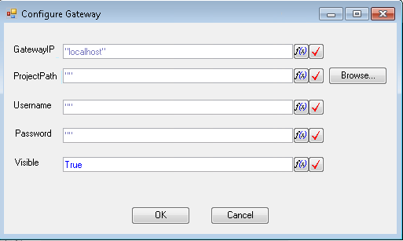

**GatewayIP – IP Address of the host gateway as a string.**

**ProjectPath – Path of the NI VeriStand project file as a TestStand string. You can use the Browse… button to browse to a path on disk.**

**Username – Username of the project.**

**Password – Password of the project.**

**Visible – If True the deployment windows appears when the project is deployed.**

## **Stop VeriStand**

This step undeploys and closes the project defined in the VeriStand.ProjectPath File Global. It is recommended that this step be placed in the Clean section of a sequence.

# VeriStand Tests

## Channel Value Limit Test

This step gets the value of channel and determines if it is within the set limits. If the value is within the limits this step passes, otherwise it fails.

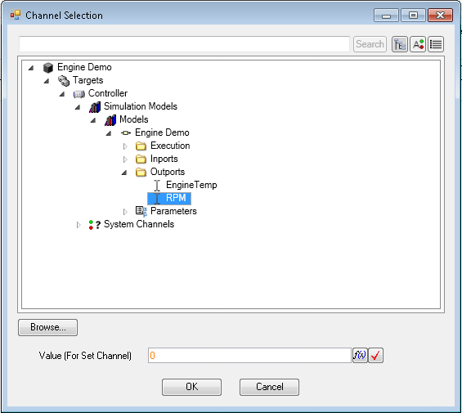

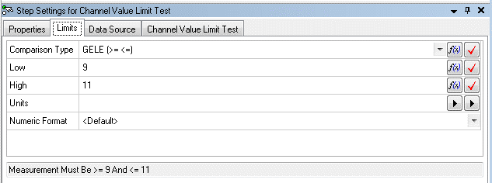

**Comparison Type – Determines which comparison to use from <=, >=, ==, !=, etc.**

**Low – The low limit to use for the comparison**

**High – The high limit to use for the comparison**

## **RT Sequence Numeric Limit Test**

This step runs a real-time sequence and uses the numeric return variable to determine if it is within the expected limits. If the value is within the limits this step passes, otherwise it fails. The associated dialog pre-loads the parameters with default values but configuration is enabled through the Browse… button and editing the parameter value.

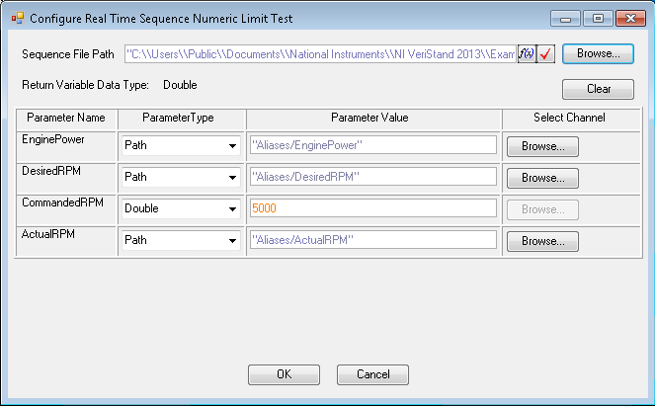

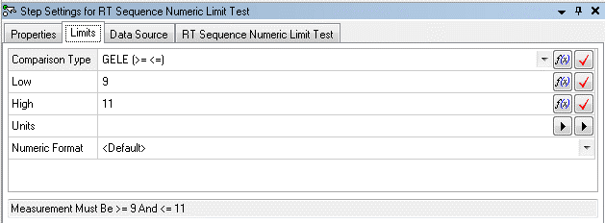

**Comparison Type – Determines which comparison to use from <=, >=, ==, !=, etc.**

**Low – The low limit to use for the comparison**

**High – The high limit to use for the comparison**

## **RT Sequence Pass Fail Test**

This step runs a real-time sequence and uses the Boolean return variable to determine if the test has passed or failed. The associated dialog pre-loads the parameters with default values but configuration is enabled through the Browse… button and editing the parameter value.

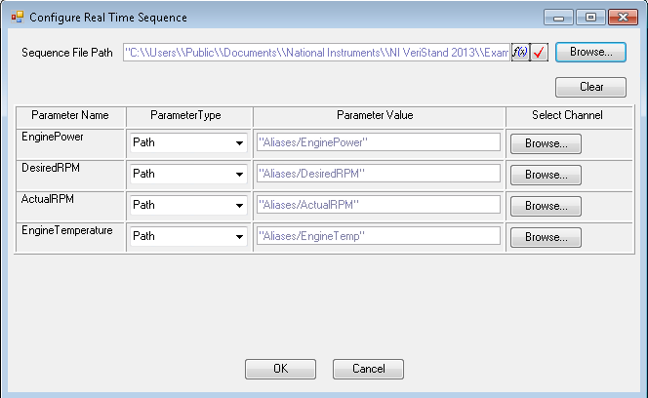

# Channels

## Get Channel Value

This step gets a single channel value and places it in the Result.Numeric container.

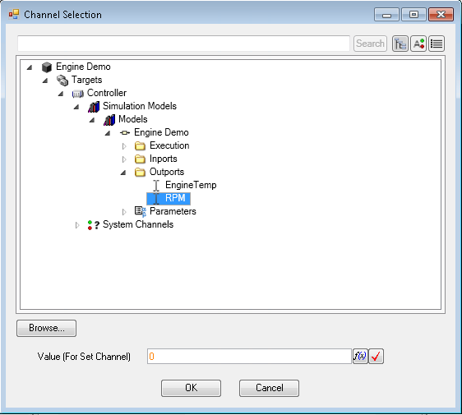

## Set Channel Value

This step sets a single channel value using the Veristand.ValueToSet and Veristand.ChannelName step variables. The step blocks until the channel update has been confirmed.

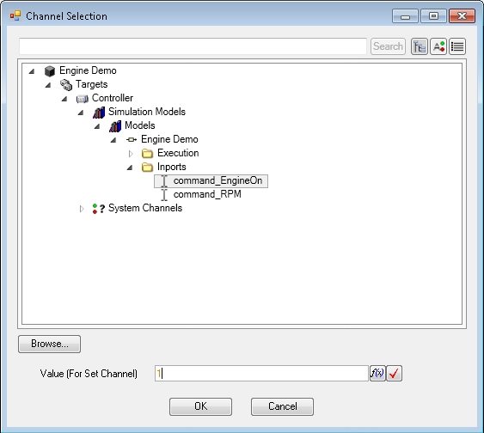

**Value (For Set Channel) – Value that the channel will be set to**

## **Get Multiple Channel Values**

This step gets multiple channel values. The channel names are placed in the Veristand.ChannelNames variable. The channel values are placed in the Veristand.ChannelValues variable.

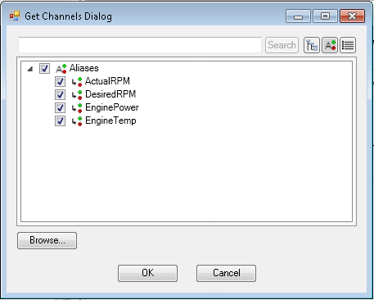

## Set Multiple Channel Values

This step sets multiple channel values using the VeriStand.ValuesToSet and VeriStand.ChannelNames. The step blocks until the channel updates have been confirmed.

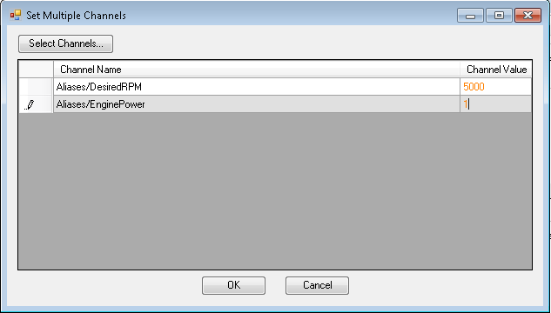

**Select Channels… - Loads a dialog to allow the user to select which channels to set**

**Channel Value – The value to set each channel to**

# **Alarms**

## Set Alarm State

This step sets an alarm to a desired state. The parameters are stored in the Veristand.FullAlarmPath, Veristand.AlarmState, and Veristand.AlarmName step variables.

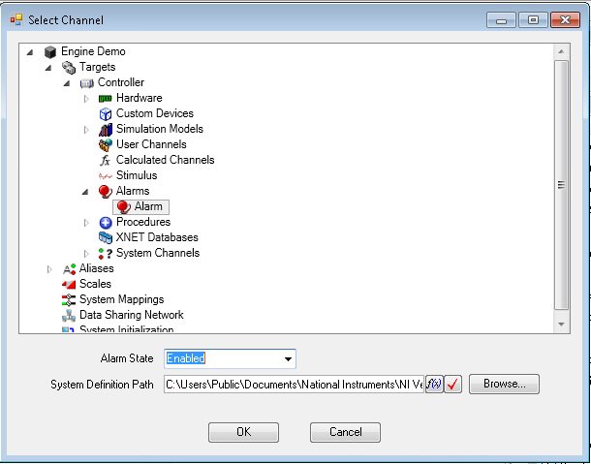

**Alarm State – The desired alarm state.**

## **Get Alarm List**

This step returns an array of strings containing all of the alarms in the system definition file. The value is stored in Result.Alarms.

## Get Alarm State

This step gets an alarm state. The state is stored in the Result.Veristand.AlarmState variable.

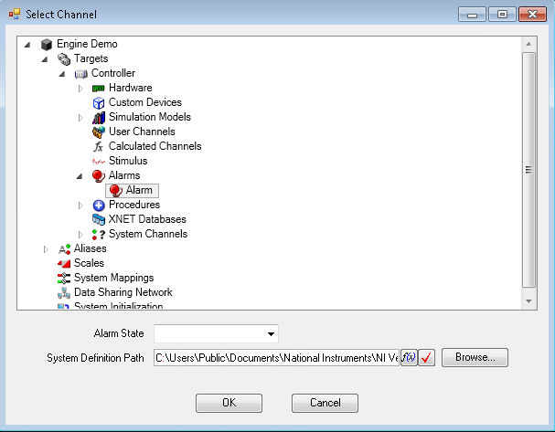

# Channel Fault

## Get Channel Fault Value

This step gets the fault value for the specified channel. The value is stored in the Result.Veristand.Numeric variable. The faulted state (True or False) is stored in Result.Veristand.Faulted. The channel name is stored in Result.Veristand.Channel.

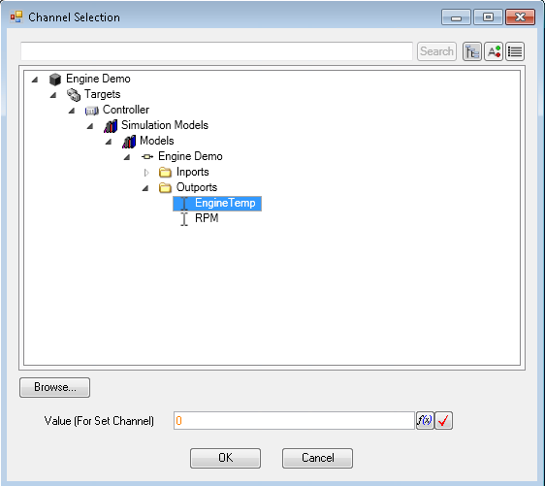

## Set Channel Fault Value

This step sets the fault value for the specified channel using the Veristand.ValueToSet and Veristand.ChannelName variables.

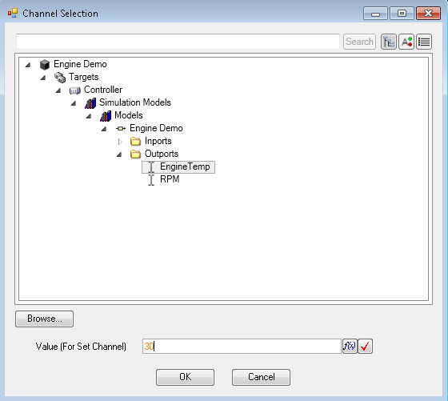

**Value (For Set Channel) – Value that the channel will be faulted to**

## Clear Fault

This step clears the fault on the specified channel.

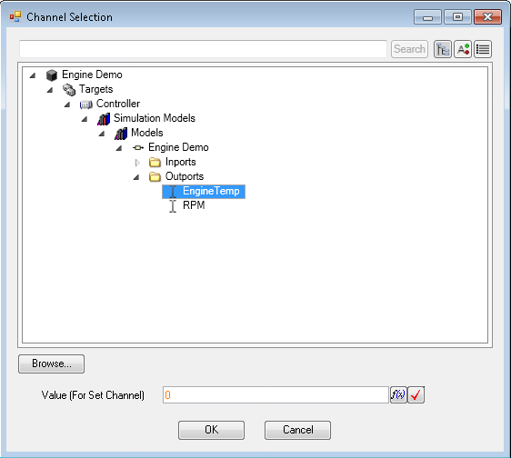

## Clear All Faults

This step clears all faults currently active on the deployed system.

# Models

## Get Model Parameter Value

This steps gets the value of the specified model parameter and stores it in the Result.Veristand.ModelNumeric variable.

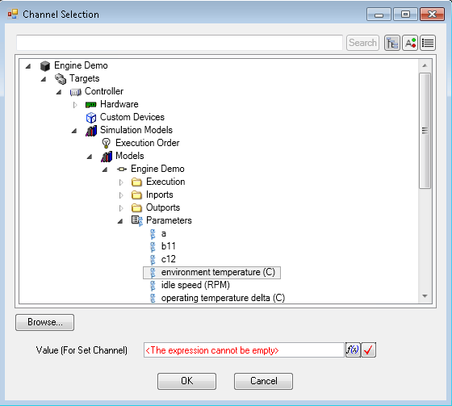

## Update Model Parameters From File

This step sets a number of model parameters at once using a specified *.m model parameter file.

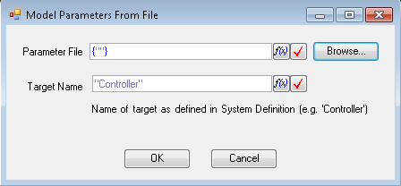

**Parameter File – The location of the parameter files as an array of strings**

**Target Name – The name of the target defined in the system definition file as a string**

## **Set Model Parameter Value**

This step sets the value of a specified model parameter using the Veristand.FullChannelPath, Veristand.TargetName, Veristand.ValueToSet, and Veristand.ChannelName variables.

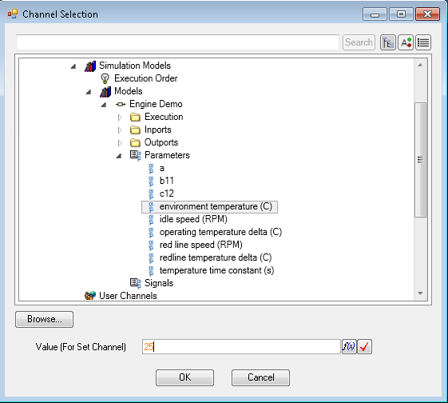

**Value (For Set Channel) – Value that the parameter will be set to**

# **RT Sequence**

## RT Sequence Action

This step runs a real-time sequence. No evaluation of the return variable is performed. The associated dialog pre-loads the parameters with default values but configuration is enabled through the Browse… button and editing the parameter value.

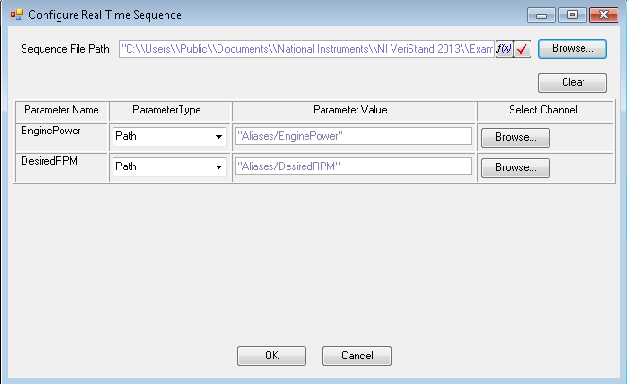

# Data Logging

## Start VS Logging

This step begins logging on the host computer. The user has the ability to select which channels to log, choose whether or not to segment, set the log path, and add advanced properties for the TDMS file. This step must always be followed by a Stop VS Logging step in the sequence.

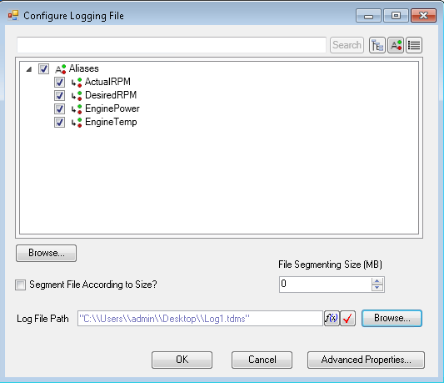

**Segment File According to Size? – True if the user would like to segment the file with size**

**File Segmenting Size (MB) – Size of the file to segment at if the Segment File According to Size? Is selected**

**Log File Path – Location of the generated log file on the host computer**

**Advanced Properties – Button to launch the Advanced Logging Properties dialog box**

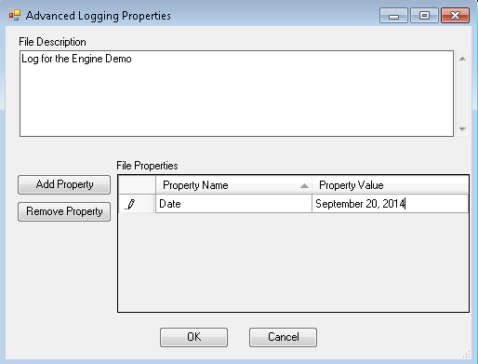

**File Description – Optional box to add a description to the log file**

**Add Property – Adds a property to the File Properties table**

**Remove Property – Removes a property from the File Properties table**

**File Properties – The list of properties which will be written to the log file**

## **Stop VS Logging**

This step stops logging on the host computer.

# Advanced

The advanced section of the Custom NI VeriStand Steps for NI TestStand allows low-level access for project, stimulus profile, and real-time sequence control. It is not recommended that users use these steps unless absolutely necessary.